Lottie loves water

By Paula McMahon

The WES Lottie Tour takes 'Lottie' to many different locations accompanying lots of different engineering friends who show Lottie the work they do in engineering and related careers.

Its primary aim is for Lottie to inspire and encourage young girls (and boys) to think of careers in engineering and STEM subjects to be open to everyone.

Read more about it at [www.weslottietour.org.uk](http://www.weslottietour.org.uk) or see Lottie’s photos on #WESLottieTour.

This book is one of a growing series which are free to download from

<http://www.weslottietour.org.uk/resources.html>.

Thankyou to Jo Parker and Elizabeth Donnelly for their vital contributions.

Lottie and Jo have been having adventures together. Lottie went to see where Jo works.

Lottie was very interested in Jo’s work as a Civil Engineer and loved that Jo was helping to save water.



What things do you love about water?

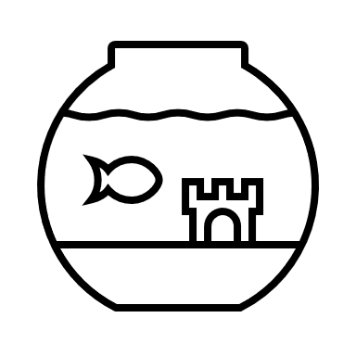

Jo told Lottie about her work on the Women’s Engineering Society Climate Emergency Group.

Jo is part of the Water Group which looks at one of the United Nations Sustainable Development Goals; known as the UN SDGs.

These are global goals, but everyone can help. Lottie was excited and had lots of questions.

UN SDG 6 is all about clean water for all

What is your favourite goal?

<https://sdgs.un.org/goals>

Lottie wondered how Jo was helping to save water at work.

Jo invited Lottie to join her for a day at work on a very large project.

Jo told Lottie how Engineers help people in different ways.



How can you save water?

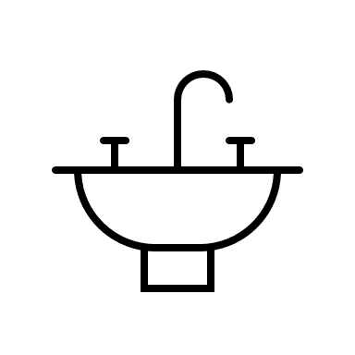

Jo helps manage our water by finding pipes which leak. This can be difficult as most pipes are buried below the ground.

But Jo does not let this stop her!

Sometimes robots from Australia help look inside pipes.

Jo told Lottie pipes could be found from clues that are everywhere.

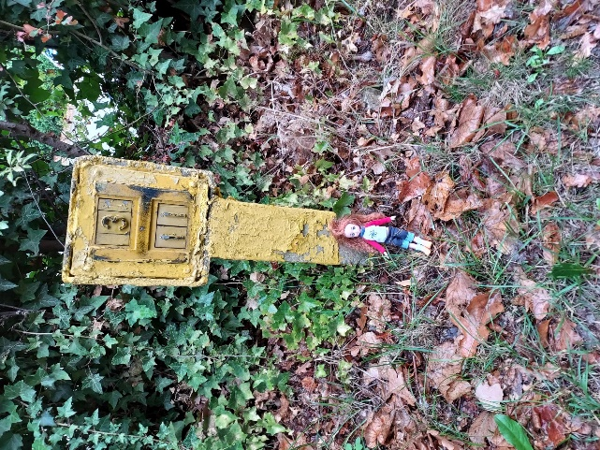

Can you find any near where you live?

Jo saves water by repairing pipes which are leaking.

Sometimes there is a big problem, or the pipes are old. These pipes get replaced with new ones.

Lottie loved watching some new pipes being laid.

What type of things do you like to fix?



Lottie visited a project which was very close to a very important old church. Jo explained that her project involved lots of digging.

Everyone was being extra careful to make sure the church was not damaged by the digging.

Jo watches what everyone does carefully. There must be no leaks before they are buried.



What things do you do where you   
take extra care?

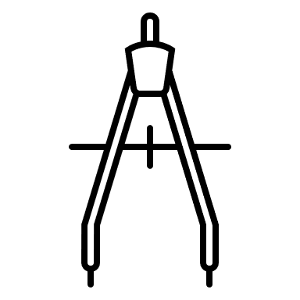

Jo cares about reducing the area she digs up.

Sometimes Jo gets help from a special machine which tunnels below ground, just like some animals.

Lottie loved sitting on this special machine!

Less digging helps people and animals that live on the surface.



What animals live underground and make tunnels?



Jo cares about people, animals and the environment.

One of her sites was near a school and there were some special hedgehogs living close by. Hedgehogs do not like loud noises.

Jo and the team made sure that works were not too noisy by using special equipment.



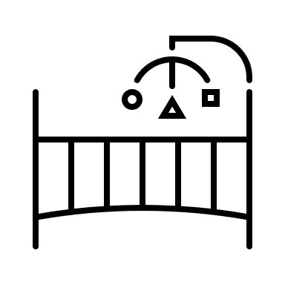

When do you have to be quiet?



Jo works very hard to help save water in her day job and at home.

She gets asked to talk about and show her work. She took Lottie to a talk she gave and to an exhibition in Italy. Lottie and Jo even visited the Leaning Tower of Pisa.

Jo wants you to help save water by reducing what you use in the garden, when taking a shower and even when you brush your teeth.

There are more ideas on how you can do this in our other Lottie Books about adventures at home and in the garden.

**The WES Climate Emergency Group**

The Women’s Engineering Society (WES) have a special group set up in response to the Climate Emergency that was declared by the UK Parliament in September 2019.

Members of the group work in lots of different areas of engineering. Everyone shares ideas and there are many different groups covering each is the United Nations Sustainability Goals – UN SDGs.

<https://www.wes.org.uk/content/climate-emergency-group>